IN SITU: Service Support for Neptune
Composite applications based on service oriented architecture embrace high complexity. Run-time analysis of composited web services is yet prone to many challenges especially at application deployment process. The problem is that the deployment process is composed of many heterogeneous tasks and artifacts that have to be orchestrated in a specific correct order. As a consequence, the automation of the deployment process is currently very difficult to reach. To address this problem, we propose in this paper an interoperable service oriented deployment framework where our approach is based on software components of all required deployment mechanisms or existing tools.
1 Introduction

1.1 Application Development Challenges
Typically, developers of client applications face a number of challenges. Application requirements can change over time. New business opportunities and challenges may present themselves, new technologies may become available, or even ongoing customer feedback during the development cycle may significantly affect the requirements of the application. Therefore, it is important to build the application so that it is flexible and can be easily modified or extended over time. Designing for such flexibility can be hard to accomplish. It requires an architecture that allows individual parts of the application to be independently developed and tested and that can be modified or updated later, in isolation, without affecting the rest of the application.
Most enterprise applications are sufficiently complex that they require more than one developer, maybe even a large team of developers that includes user interface (UI) designers and localizers in addition to developers. It can be a significant challenge to decide how to design the application so that multiple developers or sub-teams can work effectively on different pieces of the application independently, yet ensuring that the pieces come together seamlessly when integrated into the application.
Designing and building applications in a monolithic style can lead to an application that is very difficult and inefficient to maintain. In this case, "monolithic" refers to an application in which the components are very tightly coupled and there is no clear separation between them. Typically, applications designed and built this way suffer from a number of problems that make the developer's life hard. It is difficult to add new features to the system or replace existing features, it is difficult to resolve bugs without breaking other portions of the system, and it is difficult to test and deploy. Also, it impacts the ability of developers and designers to work efficiently together.

The Composite Approach
An effective remedy for these challenges is to partition the application into a number of discrete, loosely coupled, semi-independent components that can then be easily integrated together into an application "shell" to form a coherent solution. Applications designed and built this way are named composite applications.
Composite applications provide many benefits, including the following:
- They allow modules to be individually developed, tested, and deployed by different individuals or sub-teams; they also allow them to be modified or extended with new functionality more easily, thereby allowing the application to be more easily extended and maintained. Note that even single-person projects experience benefits in creating more testable and maintainable applications using the composite approach.
- They provide a common shell composed of UI components contributed from various modules that interact in a loosely coupled way. This reduces the contention that arises from multiple developers adding new functionality to the UI, and it promotes a common appearance.
- They promote re-use and a clean separation of concerns between the application's horizontal capabilities, such as logging and authentication, and the vertical capabilities, such as business functionality that is specific to your application.
- They help maintain a separation of roles by allowing different individuals or sub-teams to focus on a specific task or piece of functionality according to their focus or expertise. In particular, it provides a cleaner separation between the user interface and the business logic of the application—this means the UI designer can focus on creating a richer user experience.
[1]

1.2 Software Components
Due to the encapsulation of entities within objects, and definable associations between objects object oriented programming enables functionality to be packaged for use in different scenarios and programs, leading to programs built from sets of objects being called systems. For example, with the class Person encapsulating both the semantic and syntactic domains of a person, programs that require a similar appreciation for a person can reuse the class definition directly, rather than having to redefine the person.

To promote reuse, most object oriented languages allow classes to be compiled within libraries that can act as an API for other programs. In C# for example, programs can build reusable class libraries that package classes so that they can be used as objects local to the program itself. By changing the semantic definition of a class in a library, all programs that make use of the library also have their definition changed. [2]

Component-based Development
The definition of what is meant by a service is open to interpretation. The term component is used to describe software that is developed to deliver a specification [MS03b], rather than a realisation of a specific behaviour as advocated in OOP.
In this way, services can be constructed from components, though components themselves can act as services by encapsulating specifications for services [BJK02]. A word processor for example, could be viewed as obtaining parts of its behavior from a spelling checking service, a printing service, and other services that can be abstracted from the program. In a similar abstraction to object-oriented programming, by encapsulating a behaviour within a service, changes in the behaviour of a service are reflected in all programs that consume the service.
As each language attaches its own semantic understanding of what is meant by an object or component, to standardise the development of components, so that those written in one language could be reused within another, numerous component models have been developed to support component-based development. Microsoft COM (Component Object Model), introduced in 1993, provided a set of standard interfaces that components must adhere to so that COM compatible languages could communicate with the components [GHL+98]. In addition, Sun Microsystems introduced JavaBeans to provide similar functionality specific to Java, as described in [HC01]. [2]
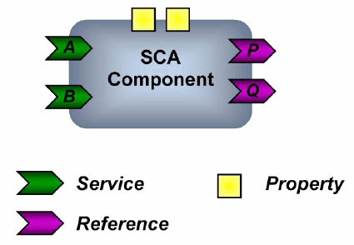
2 Problem Statement
SCA also brings flexibility to deployment. A solution assembled with SCA is deployed as a unit and can be distributed over one or more nodes in the network and can be reconfigured without programming changes. Applications that adopt SCA programming model can interact with non-SCA applications. Meaning non-SCA application can call into SCA enabled applications and SCA enabled applications can call out into non-SCA enabled applications. SCA allows multiple technologies to be used to implement services (e.g. Java, BPEL, C++) and multiple bindings for communicating with services (e.g. Web services or JMS). However, SCA does not describe how you would introduce a new implementation type or new binding into a runtime. This is exactly where JBI is targeted. As SCA asserts, its service component metadata is platform independent so it is possible to use it with any service implemented on the Java Platform. The focus of JBI is to provide an extensible Java Platform server facility that simplifies how multiple server-side programming facilities such as Servlets, EJBs, JavaScript, BPEL, business rules, data transformation, etc. can work together within a Java Server environment. This allows a Java server-side application to mix-and- match the facilities it needs to effectively implement its function. [3]

Neptune doesn’t fit composite application architecture, because it lacks the annotation of component interoperability and loosecoupling, thus we managed to harvest into Service Component Architecture (IBM, Oracle), and aimed to atomize semantics of the model architecture, we then claimed to present aspect oriented approach of SCA artifacts.

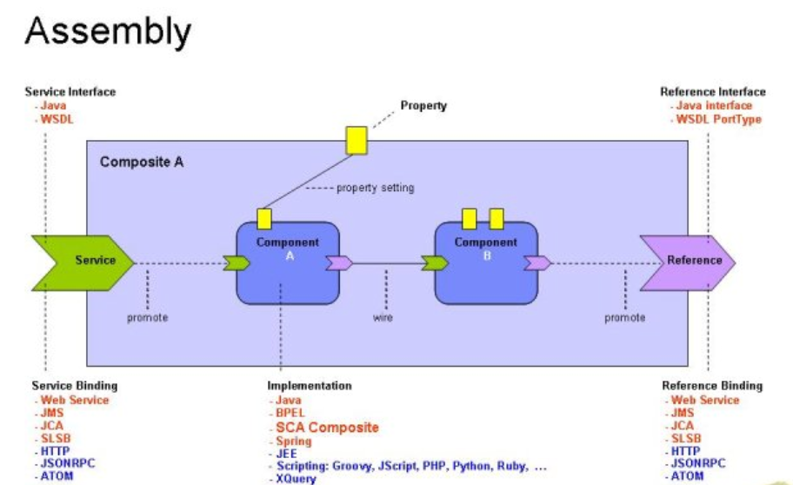
3 Proposed Solution
We are investigating in semantic axioms embraced between programming paradigms like "declarative programming", "imperative programming", "aspect oriented programming" and "meta language programming" to support "process oriented programming" using "autonomic computing".
We know that "aspect orientation" of business process workflow and/or choreography is almost mature and done via AO4BPEL and others, but still language support is missing, in terms of linking/managing cross-cut concerns at pointcuts to do support to declarative extraction of code.
Since this can all be applied in software application architecture even MDA/MDD (UML modeling,....etc) to consistently manage user functional/non-functional requirements at design time.
Run-time aspects/problems for managing functional/non-functional user requirements are not yet well investigates especially when you do pragmatic and reliable shift from old fasioned software application development methodologies into composite applications where you have more layers in the application stack (people, business rules, assets, processes, workflows, workload...ect) and you want to manage them effectively.
Here comes the challenge and the need to build support models and architectures in order to bridge the gap between software application model design and runtime and composite application model design and runtime.
An example you may take like take a pure legacy programming algorithm from oop even you may take oop pattern development, try to design it, debug it and run it and test results, then at runtime try to monitor code, logic, presentation layers of the program, you will definitely realize that the code is parsed, analyze structure, draw syntax code tree, interpreted to meta language, then complied. So many frameworks do this like J2EE or .NET with the aid of intermediary CLR's other model based programming languages like UML used to model and write code to support program functionality.
When you go to composite applications (SOA apps) you will find totaly different story, actually the whole legacy software application paradigm is one layer in SOA composite application stack which covers subsidiary layers for handling objects, logic, data and their interaction.
We reached a point in which we invented an evolving meta language support for software application architecture at the language level called Neptune. Where Neptune had bridged the gap for any language programmer (language independent support) of consecutively emerge codebase (functions, logic, constraints, data,....etc) into more aspect based objects called Neptune Base Language Objects, NBLO's can carry several aspects from all layers (logic, data and presentation) in one object (a scripting , XML and SOA "WSDL" representation is also done). NBLO's had demystified the concept of meta programming and though eliminated the programmer's efforts when examining code (tracking changes,....etc) at runtime by intuitively facilitate monitoring, analyzing and actuating code behavior at runtime regardless the compiler was. By this inception a programmer can only focus on aspects and code functionality rather spending time on design of modules/objects and their persistence.
Then a more human oriented concept been motivated called Intention Model, where the programmer makes himself more real-life oriented. The intention model is a container of which the programmer can express (an extensive effort to mimic human based language) the intended model to be developed as directives (XML) these directives are more linked to whole picture of the problem as opposed to programming the problem, like goals, functionaliteis, requirements (functional/non-functional),....etc. Neptune framework powerful means will do the rest by taking the intention model from higher level stages to low level ones NBLO's and rules in CA-SPA's,
The Neptune framework is now witnessing very pragmatic improvement by adding more support components, models and now comes the need to add architectures to it to link everything together. Neptune effect/influence came to a very critical edge when entering real life of composite SOA applications. Here we captured business scenario like PetStore/PetShop, we traveled with business workflow as business logic and stated application layers from its module functions, database, objects and their behavior, we build NBLO objects then used Neptune scripting support to get Neptune tasks and processes, we strive to exercise methods/function behavior and their impact on application layers (presentation, logic and data) when some function/method fetches parametric aspects like attributes. We reached a fact state that method/function attributes are linked in their context to functional/non-functional requirements of the application. We examined traverses of changing these attributes at runtime, how would application and its elements/components behave and how to adaptively manage this change to keep stable adoption for these changes and their impact on application total behavior. We use here autonomic computing paradigm of self-configuring, self-optimizing, self-securing, ........self-*.
We are now in a stage to seek more business/life acquisition of software application architecture when achieving/satisfying functionalities as well as programmer intentions from Intention Model at runtime playing in SOA architecture of composite application architecture, we engage user level interaction by managing tasks, form elements, roles, documents. We will challenge the use of language support to reconcile the analogies between software programming architecture and SOA composite application from an anatomy based perspectives. We will seek to answer questions like what architectural artifacts needed and models to adapt change in user requirements at run time on behavior of composite services/components.What is the necessary language support should be provided (new constructs, constructs behavior) to manage process orchestration at runtime inside composite application container. How do assure system availability, stability due to change in its architectural elements/artifacts/components at runtime.

Scenario

Petstore/petshop business process scenario where a language support of framework called Neptune which include major 4 components as an intermediate semantic language syntax interpretation; these components belong to aspect programming concepts where a codebase can be re-structured/re-factored in simple components called NBLO's, Neptupe Base Language Objects, these components are expression representations of codebase methods/functions; NBLO's can contain semantic language logic, then with aspect oriented approach NBLO's can be cross-cutted into logical concerns as tasks then a process is a combination of tasks, as you may see, this process can be represented of course being injected with logic to a BPEL process, the whole idea is to "transform" Neptune tasks and processes to SCA "Service Component Architecture" or JBI, what is required to run this process at runtime, all transactional interactions between Neptune engine (language support) and JBI container including issues of BPM like audit trail, compensation, event handling, fault handling, advanced composition, workflow patterns,...etc

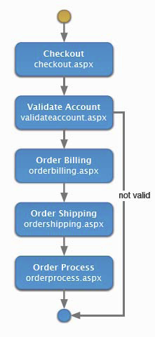
We need to keep in mind that not only model transformation of Neptune process will give enough information about codebase behavior, thus we will start from the NBLO object itself, an interoperable representation of NBLO object will give ensure the following:
- Full interoperability with other models of WS-I like WS-Annotation, WS-Security
- Support to messaging should be included like design of end-point addressing styles which will give invocation capabilities to the NBLO object via WSDL messaging style
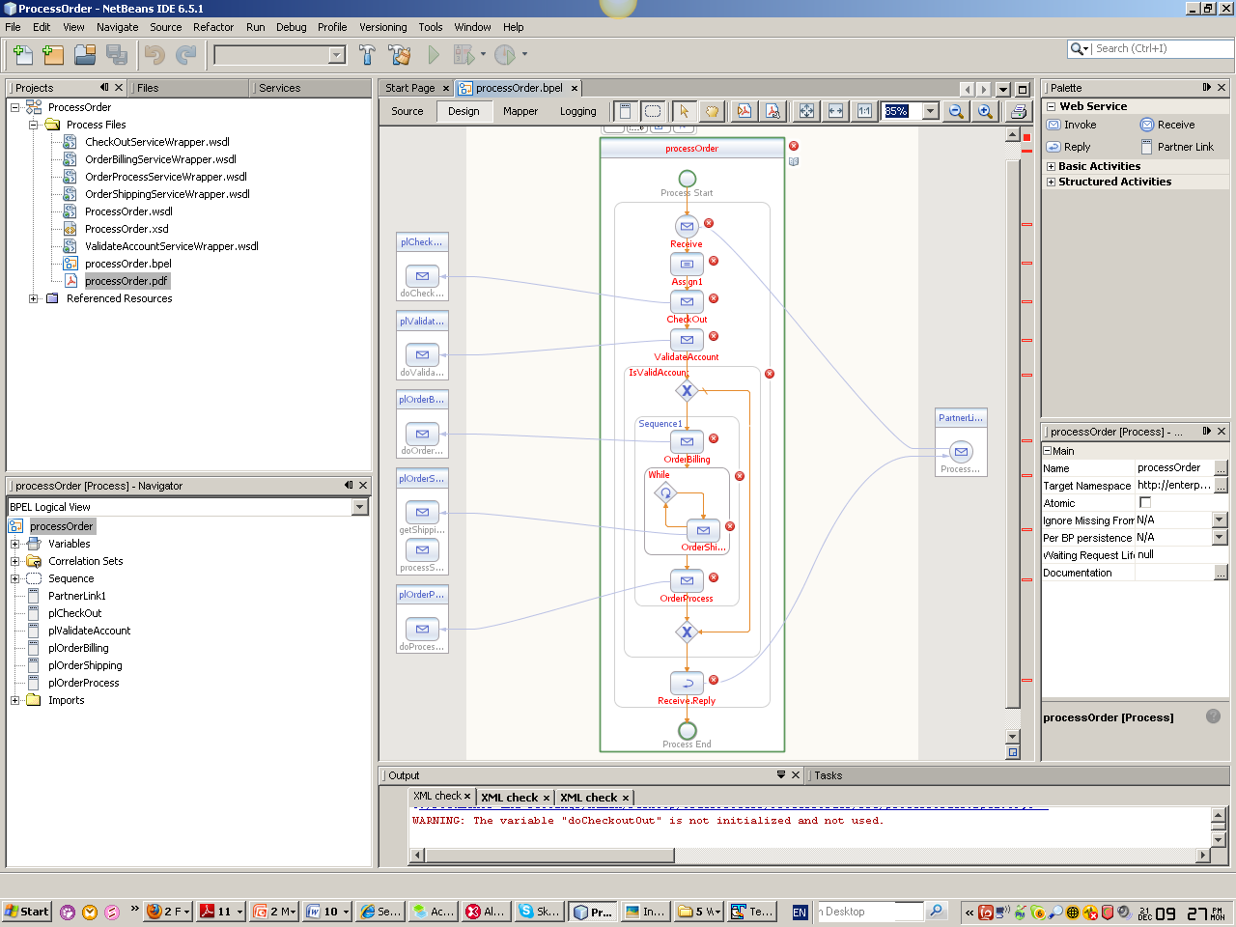

We've been working on rewriting the classic "Java Pet Store" application as a BPEL orchestration. It has been a great exercise to understand how one might develop entire applications using a service based model. The application ties together a variety of services (Presentation Services, Logic Services, Data Manipulation Services, Data Persistence Services, etc.). The penetration between these tiers at runtime shows some hindrance, especially at routing messaging or calls between elements, there comes the need for message broker component to provide more flexible and manageable support of Reliable Messaging between elements and at runtime.
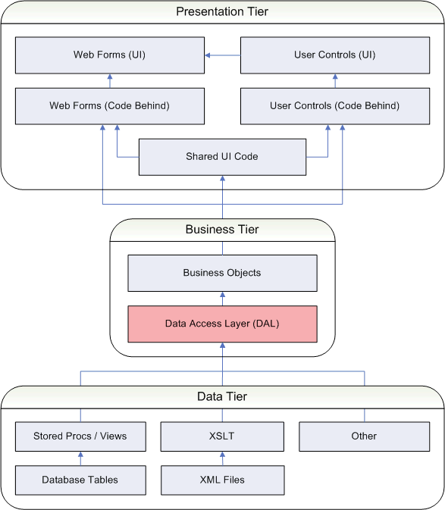

We used Java Business Integration and its internal service BPEL engine for orchestrating Web Services “Sun BPEL Engine” and to utilize services written in Java (on the J2EE model). What we addressed as challenges:
- The granularity of the J2EE model is currently too fine grained to be mapped directly to service based architecture.
- The J2EE programming model is a bit “location aware”, its design architecture rendered with “tiers”
- The concept of "Location Transparency" or “Aspect Oriented approach” is yet still in infancy.
- Candidate service model can be created by using UM sequence diagram
- Meta-meta mode (MOF), or some other meta data facility MUST be a key component of the fabric
define nbloOrderShipping with NString orderID
{purpose
{
feature ShippingAddress to orderID;
feature ShippingPostcode to orderID ;
feature ShippingBand to orderID ;
}
actuation
{
// call the presentation layer
call
BaseLanguage.Csharp(”orderPL.dll”, ”getShipping”, orderID,sync);
}}

// logic layer component
define nbloSaveOrderShipping with NString orderID
{purpose
{
feature orderID.Shipping to Database ;
}
actuation
{
// call the logic layer
call BaseLanguage.Csharp(”orderLL.dll”, ”processShipping”, orderID,sync);
}}

Task syntax
task OrderShipping with NString orderID
{requirements
//need data
needAddress:require orderID.ShippingAddress;
needPostcode:require orderID.ShippingPostcode;
needBad:require orderID.ShippingBand;
saved:require Database.Shipping(orderID);
}
actions
{needAddress.needPostcode,needBand via nbloOrderShipping;
saved via nbloSaveOrderShipping;

The resulted Neptune process :

process processOrder
{tasks
{if (validateAccount == false}
end;
orderBilling giving orderID;
orderShipping (orderID);
orderProcess (orderID);
}}
Will be

define nbloOrderShipping with NString orderID
{purpose
{
feature ShippingAddress to ordered @ maximum;
feature ShippingPostcode to orderID ;
feature ShippingBand to orderID ;
}
actuation
{
// call the presentation layer
call
BaseLanguage.Csharp(”orderPL.dll”, ”getShipping”, orderID,sync);
}}

// logic layer component
define nbloSaveOrderShipping with NString orderID
{purpose
{
feature orderID.Shipping to Database ;
}
actuation
{
// call the logic layer
call BaseLanguage.Csharp(”orderLL.dll”, ”processShipping”, orderID,sync);
}}

Neptune Transformation for Composite Application Architecture

NBLOX and CAS-PAX

The definition of Neptune base Language Objects is that it is a runtime object carries cross-cut concerns about the program logic. The existing architecture of NBLO objects however need to be extended to support interoperability, thus by leveraging the XML representation of NBLO to be able to add self-annotations at runtime to its skeleton, We introduced the task object which is an order to steer code behavior:

<task name="OrderBilling " portType="wsdl:OrderBilling PT" operation=" OrderBilling " xmlns:xsi="http://www.w3.org/2001/XMLSchema-instance" targetNamespace="http://jbi.com.sun/wfse/wsdl/WorkflowApp2/OrderBilling "
xmlns="http://jbi.com.sun/wfse"
xmlns:cur="http://www.sun.com/wsbpel/2.0/process/executable/SUNExtension/XPathFunctions"
xmlns:wsdl="http://jbi.com.sun/wfse/wsdl/WorkflowApp2/OrderBilling _TM_BPEL"
xmlns:po="http://wlmse.sample/po">
<import namespace="http://jbi.com.sun/wfse/wsdl/WorkflowApp2/OrderBilling _TM_BPEL"
location="OrderBilling _TM_BPEL.wsdl"/>
<!-- Make sure to use single quotes for literal value in xpath enabled expression -->
<title expressionLanguage="urn:oasis:names:tc:wsbpel:2.0:sublang:xpath1.0">'This is a purchase order'</title>
<!-- priority is in 1-10 scale with 10 to be the highest -->
<priority expressionLanguage="urn:oasis:names:tc:wsbpel:2.0:sublang:xpath1.0">'5'</priority>
<assignment>
<!-- 0-* objectB -->
<object>'RefactoringObject'</object>
<!-- 0-* group -->
<group>'CompositionGroup'</group>
</assignment>
</task>

We present the interoperable NBLOX :

<nblox type=””>

</nblox>

For imperative programming language such as Java, C#, or JavaScript, we should consider the benefits of declarative programming when designing next our application. exploring the benefits of the following technologies:
- XML Schema
- ISO Schematron
- XForms/XBL (XML Binding Language)
- XSLT 2.0
- XQuery
- Atom Syndication
- AtomPub
The basic difference between declarative programming languages and imperative programming languages such as C# and Java is that the former specify the “what” (the intent) as opposed to the “how” (the algorithm). The following are some reasons to consider this new paradigm:
- Declarative programming languages are accessible to many non-programmers
- It’s possible to create a solution that is completely declarative (no Java, C#, JavaScript, or AJAX code)
- It facilitates the Model-Driven Architecture (MDA) software design approach
- When the data or content is managed in XML, a declarative programming model is a superior and simpler alternative to a conventional approach based on Java Server Faces (JSF), Spring, and Hibernate. For example, we get a more robust and simpler data and business rules validation mechanism and we can forgo ORM mapping altogether. However, declarative and imperative programming can co-exist in the same solution.
The following are some recipes for taking advantage of this new paradigm:
- Define data structures and types in the XML Schema.
- Use XML Schema's xsd:appinfo element to:

  - Capture metadata such such as XML to RDBMS mapping information
  - Capture business rules using inline ISO Schematron rules
  - Control the labels, alerts, and appearances of UI components such as XForms controls.
- Generate UI by transforming the XML Schema into XForms with XSLT.
- Alternatively, store XML schema and other XML-formatted metadata artifacts in a native XML database and use XQuery to extract and manipulate the metadata during development and at run-time.
- The use of XBL for enabling custom UI controls for your XForms. As an example, you can integrate a rich text editor using XBL and Dojo.
- Use ISO Schematron for business rules validation either post form-submission or by using XSLT to inject schematron rules into the XForms directly with the xforms:bind element.
- Use the RESTful or AtomPub API to a native XQuery-enabled XML database (such as Exist) to CRUD (create, read, update, delete) the data.
- If using SOAP-based web services, then we should use XForms to send SOAP requests and display SOAP responses as well.
- Leverage Atom syndication for pushing updates to data consumers. In general, when creating your application, think "Syndication Bus".
Many software architects and developers are not yet aware of the power of this new paradigm. However, I believe that rather than using only familiar development frameworks, it’s important to always evaluate emerging alternatives and select the best approach even it involves a learning curve.
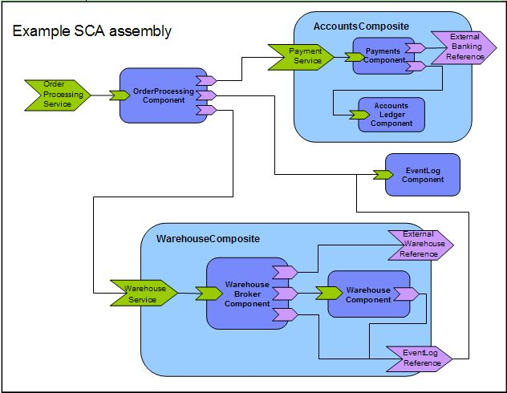

Service Model of Process Order
Its conceivably obvious as shown that the meta model of composite application architecture should contain raw elements of service components and service assemblies. With Service Component Architecture (SCA) and Service Data Architecture (SDA) these components have only service interfaces and thus the representation of software application tries can be fine grained service components for each of type data, logic and presentation. SCA model doesn’t prevail any runtime support components, while some known implementations that support runtime manageability over SCA like Apache Tuscany and Fabric3 provide support of service components interaction and process orchestration through binding API’s to BPEL,..etc

